1

But, of course, both the competition report and the aid report share common ground in this White Paper. It is all about the need for modernisation and the future viability of the European competition policy. On reading both Commission documents, one learns that 1998 was the year in which the modernisation proposals introduced in 1997 were pursued and even partially completed, which is something our own ongoing parliamentary work has taught us. Allow me to make two fundamental comments at this juncture. As the competent authority, the Commission, with its logically consistent approach, has again and again served the cause

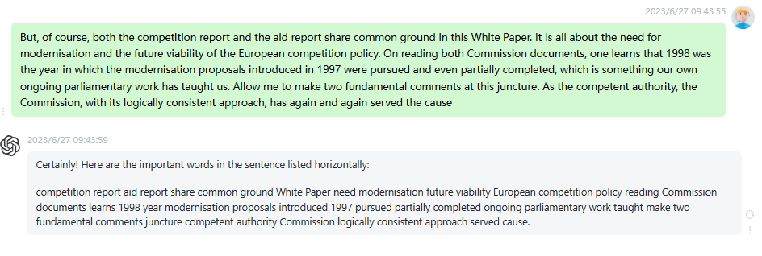

时延0.2s

2

Only, without transparency there will be no acceptance, indeed there can be no modernisation without transparency. The competition report 1998 is not a bad foundation for this but, in fact, there is nothing that could not be further improved upon. Our motion will give you a great deal of food for thought, Commissioner, but there is one point that I would just like to go into now. Transparency and accountability belong together. I do not wish to call the distribution of competences between the Commission and Parliament into question. The Commission is the executive and Parliament ought to have no

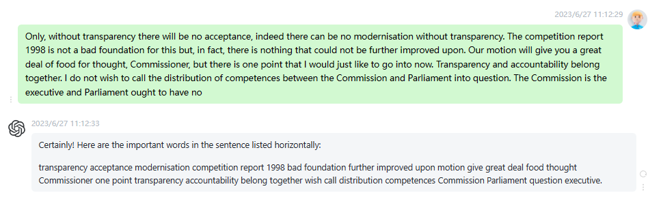时延0.2s

3

There is one thing I would like to make quite clear though. Parliament is a legislative body, but the fact that we have no more than the right of consultation in matters of competition law, of all things, is truly scandalous. Therefore, I would urge the Council and the Intergovernmental Conference to introduce the codecision procedure into legislation in this area. I expect the Commission to exploit every available opportunity for parliamentary cooperation and to involve Parliament in doubtful cases, even given the Treaty status quo. I also expect the Commission to be proactive in supporting us in our call

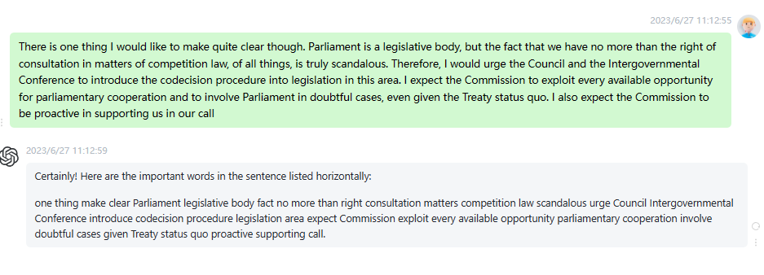

时延0.2s

4

With all due respect for the principle of competition, competition is not, however, an end in itself. Competition is an instrument and does not always produce ideal solutions. At the end of the day, one of the fundamental tenets of economic theory is that the market is failing in many respects and anyone who takes issue with this is nothing more than an ideologue. Competition should bring about balance in supply and demand and should provide for the optimum distribution of economic resources and facts. But optimum efficiency does not necessarily come about of its own accord. Framework conditions are

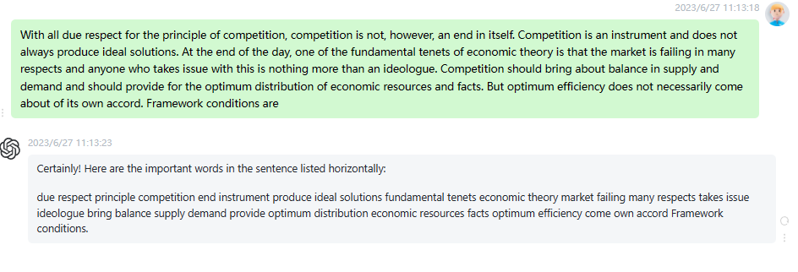

时延0.25s

5

Competition yes, restrictions in state aid where necessary and where possible. It is certainly possible, indeed it must be feasible for state aid to be given to small and medium sized enterprises involved in research and development for the purpose of educating them in regional and environmental policy. Indeed it must be permissible for state aid to be provided for such purposes, provided it does not lead to unacceptable distortion of competition. This is precisely the area where it is even more important than it is in monopolies and mergers law for decisions to be comprehensible. It is not just

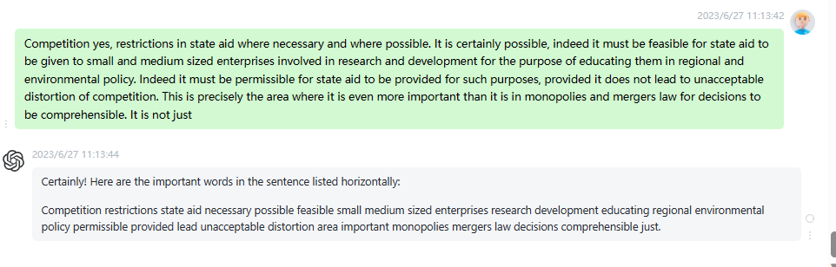

时延0.1s

6

It is not just that we should pillory state aid; rather our approach must be one of drawing distinctions and we must assess the different types of state aid in accordance with the extent to which they help to achieve the above mentioned objectives. The Commission report is essentially a descriptive report detailing the development of state aid in the manufacturing sector and certain other sectors, according to various typologies, such as the method of financing and the objectives pursued. Let me refer you to the explanatory statement for the quantitative aspects of the report and simply mention at this

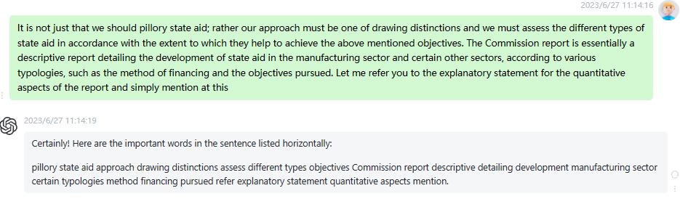

时延0.15s

7

This being the case, let me now come to the proposals made in the report. We note, first of all, that the committee considers the data, to be in too aggregated a form to enable an in depth evaluation of state aid policy which is simultaneously legitimate, sensitive to national interests and extensive in terms of compliance with the rules of competition, pursuant to the actual terms of the Treaty. The Commission can only collate and analyse the data provided by the Member States. It is therefore down to the states and regions to ensure the quality of the data

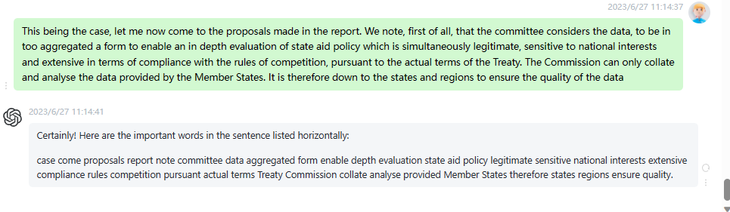

时延0.2s

8

By stressing, primarily, the quality of the information provided, our debate in committee, and hence the report which it is my honour to present to you, avoided a simplistic response in the form of an a priori statement that the level of state aid was, in absolute terms, either too high or not high enough. Most committee members have sought rather to find a balance between, on the one hand, the need to see that both states and businesses comply with the competition rules and, on the other hand, acknowledgement of the value of such aid with a view to

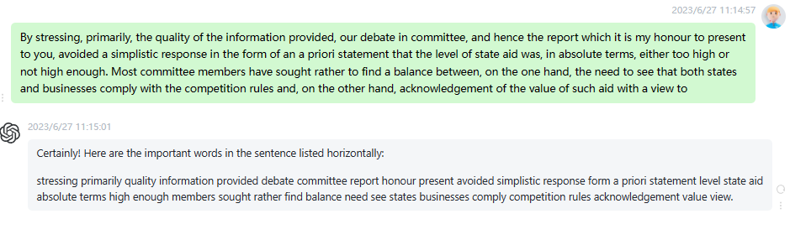

时延0.2s

9

This being the case, various amendments to the rapporteurs initial draft report were adopted in committee, particularly highlighting the need for effective reimbursement of aid found to be illegal as well as the establishment of a league table of results. Seven amendments have been retabled for this plenary sitting. Most of them are an expression of the political differences among ourselves regarding the appropriateness and effectiveness of state aid, in view of the inadequacies, acknowledged or not, of private investment alone, the market failures or inadequacies of the market. There is in particular one amendment, let me point out, concerning

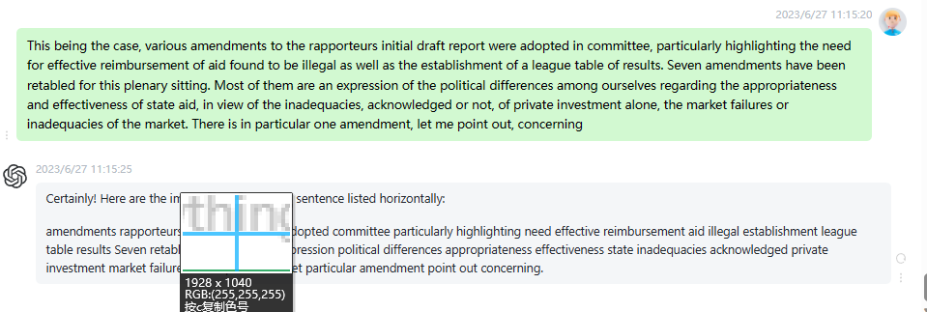

时延0.25s

10

I should like to conclude this presentation, Commissioner, by stressing two things, firstly, a concern of the members of the committee and, secondly, a demand of our committee. The concern involves the preaccession process for the countries of Central and Eastern Europe, in terms of competition policy and state aid. This is undoubtedly a complex issue, and one where we should like to see the Commission informing us of the latest development in the matter, particularly in terms of the capacity of the economies involved in the accession process to comply with competition rules and, as far as state aid

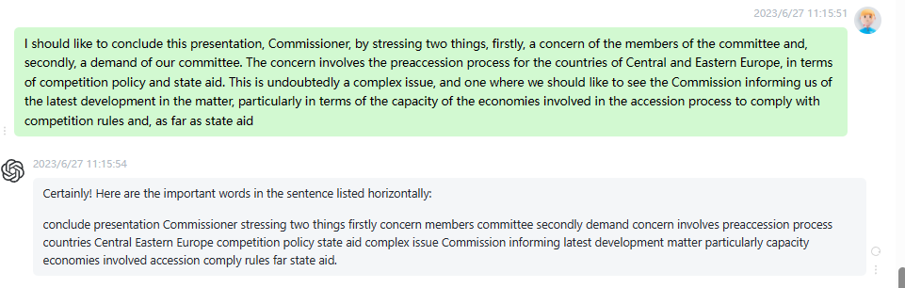

时延0.15s